Crunch Base - SQL Project

**Few insights may include:**

* which countries(Top 2) most investors are from?

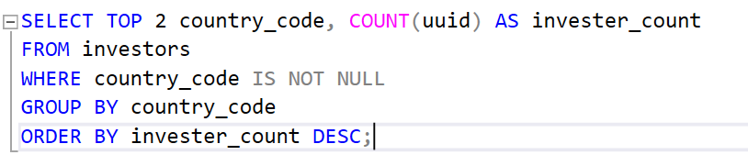

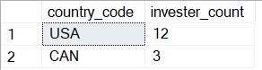

* How many investors have investment partners?

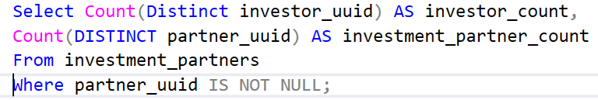



* Distribution of investors between Organization and individual person

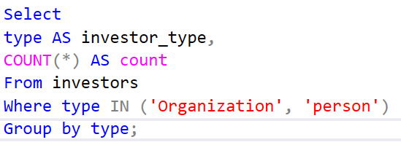

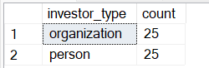

* Regional Analysis of investors Top 2

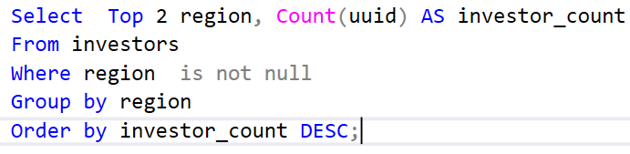

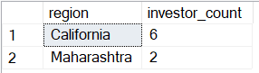

* Analysis of social media presence of investors

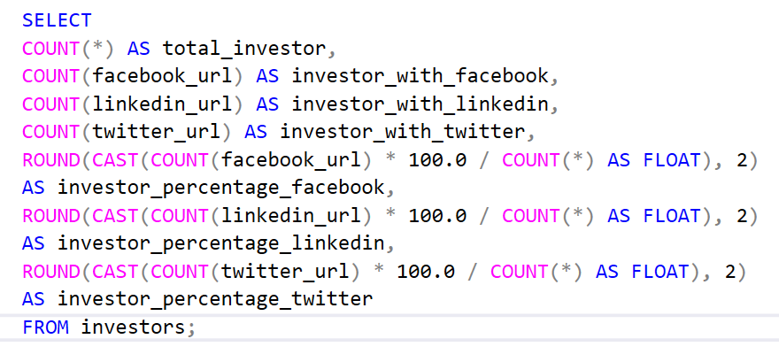



* how many people completed degree

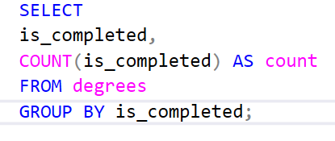

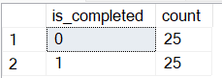

How many peoples in which degree enrolled

